**2- Reflection**

Reflection along a line passing through origin making an angle $θ$ with x-axis in anticlockwise direction is a transformation T: R2R2 defined as

**T () =A + , ∈ R2**

Where,

A $=\left[\begin{aligned}\cos{2}θ \sin{2θ} \\ \sin{2θ} -\cos{2}θ\end{aligned}\right]$

**Reflection over/along the y-axis**

$$T(\vec{x})$$

Y

X

(x, y)

(-x, y)

$$\vec{x}$$

Along y-axis with $θ$ = $\frac{π}{2}$

A = $\left[\begin{matrix}cos2(\frac{π}{2}) & sin2 (\frac{π}{2}) \\ sin2(\frac{π}{2}) & -cos2(\frac{π}{2})\end{matrix}\right]$

= $\left[\begin{matrix}-1 & 0 \\ 0 & 1\end{matrix}\right]$

$$T(\vec{x})$$

Y

X

(x, y)

(x, -y)

$$\vec{x}$$

$T\left({x \atop y}\right)$ = A $\vec{x}$ = $\left[\begin{matrix}-1 & 0 \\ 0 & 1\end{matrix}\right]\left[\begin{matrix}x \\ y\end{matrix}\right]$ = $\left[\begin{matrix}-x \\ y\end{matrix}\right]$

**Reflection over/along the x-axis**

Along y = 0, $θ=0$

A = $\left[\begin{matrix}Cos2(0) & Sin2 (0) \\ Sin2(0) & -Cos2(0)\end{matrix}\right]$ = $\left[\begin{matrix}1 & 0 \\ 0 & -1\end{matrix}\right]$

$T\left({x \atop y}\right)=\left[\begin{matrix}1 & 0 \\ 0 & -1\end{matrix}\right]\left[\begin{matrix}x \\ y\end{matrix}\right]$ = $\left[\begin{matrix}x \\ -y\end{matrix}\right]$

**Reflection along the line y = *x* with $θ=π/4$**

A = $\left[\begin{matrix}Cos2(π/4) & Sin2 (π/4) \\ Sin2(π/4) & -Cos2(π/4)\end{matrix}\right]$ = $\left[\begin{matrix}0 & 1 \\ 1 & 0\end{matrix}\right]$

$$T(\vec{x})$$

Y

X

(x, y)

(y, x)

$$\vec{x}$$

y = x

$T\left({x \atop y}\right)=\left[\begin{matrix}0 & 1 \\ 1 & 0\end{matrix}\right]\left[\begin{matrix}x \\ y\end{matrix}\right]$ = $\left[\begin{matrix}y \\ x\end{matrix}\right]$

**Reflection along the line y = -x**

with $θ=90°+45°=135°$

$T\left({x \atop y}\right)=\left[\begin{matrix}0 & -1 \\ -1 & 0\end{matrix}\right]\left[\begin{matrix}x \\ y\end{matrix}\right]$ = $\left[\begin{matrix}-y \\ -x\end{matrix}\right]$

**Example 1. (Reflection of Triangle)**

Reflect the triangle with vertices A= (2, 4), B = (2, 2), C = (6, 2) along x-axis, y-axis and y = -x.

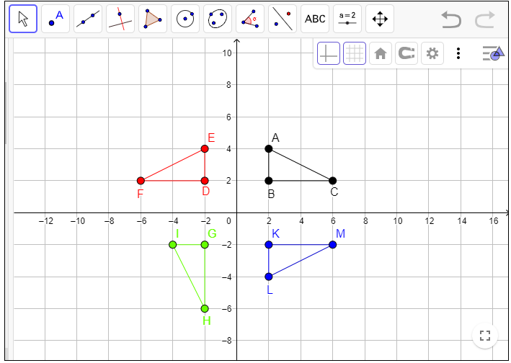

**Example 2. (Reflection of a line)**

Let y = 2x +1 be a line. Find the reflection of that line along the line y = x.

Solution. First of all we will find the angle of the line y = x with the x-axis about the origin.

y = x (General form of line is y = mx + c)

So, m =1, tan $θ$ = 1 $⟹$ $θ$ = 45 $°$

Here, A = $\left[\begin{matrix}Cos2(45°) & Sin2(45°) \\ Sin2(45°) & - Cos2(45°)\end{matrix}\right]$ = $\left[\begin{matrix}0 & 1 \\ 1 & 0\end{matrix}\right]$

Therefore, **T ($\vec{x}$) = A $\vec{x}$**

$\left[\begin{matrix}x' \\ y'\end{matrix}\right]$ = $\left[\begin{matrix}0 & 1 \\ 1 & 0\end{matrix}\right]$ $\left[\begin{matrix}x \\ y\end{matrix}\right]$ = $\left[\begin{matrix}y \\ x\end{matrix}\right]$

So, $x$ = $y'$, $y$ = $x'$

Y

X

y = 2x+1

$y^{'}$ = ½ $x^{'}$-1/2

Put x and y in original line y = 2x + 1

$x'$ = 2 $y'$ + 1

Or 2 $y'$ = $x'$- 1

So $y'$ = 1/2 $x'$- 1/2 is the reflected line.

To draw original line y = 2x + 1 take two points on it, let A = (1, 3) and B = (2, 5).

And to draw the Reflected line $y'$ = 1/2 $x'$- ½, $A'$ = (2, 1/2) and $B'$ = (4, 3/2).

**Reflection of circle**

Let (x-2)2 + (y-3)2 = 4 be a circle. Find its reflection along the line y = -x

Solution.

First of all we will find the angle of line y = -x with x-axis at origin line.

That is for m = -1, $θ$ = 135 $°$.

The transformation of reflection is

**T () =A, ∈R2**

Where

A = $\left[\begin{matrix}Cos2(135°) & Sin2(135°) \\ Sin2(135°) & - Cos(135°)\end{matrix}\right]$ = $\left[\begin{matrix}0 & -1 \\ -1 & 0\end{matrix}\right]$

As, **T ($\vec{x}$) =A $\vec{x}$**

$\left[\begin{matrix}x' \\ y'\end{matrix}\right]$ = $\left[\begin{matrix}0 & -1 \\ -1 & 0\end{matrix}\right]$ $\left[\begin{matrix}x \\ y\end{matrix}\right]$ = $\left[\begin{matrix}-y \\ -x\end{matrix}\right]$

$⇒$ $\begin{matrix}x^{'}=-y \\ y^{'}= -x\end{matrix}$

Putting $x$ = $-y^{'},$ $y$ = $-x'$ in the original circle (x - 2)2 + (y - 3)2 = 4, we get

2 + 2 = 4, reflected circle.

As original circle (x - 2)2 + (y - 3)2 = 4 is with Centre = (2, 3) and Radius = 2

While Reflected circle 2 + 2 = 4 has Centre = (-3, -2), Radius = 2. We can draw both circles easily.

**Example.** Reflection of a line along a line which is not passing through origin.

Let y = x+2 be a line. Find its reflection along the line x =1.

Solution: Now first we will shift our line x =1 at origin. For this purpose we have to subtract vector $\left[\begin{matrix}1 \\ 0\end{matrix}\right]$. Our line become x = 0. So our $\vec{x}$ vector can be written as:

$\vec{x}$**= $\left[\begin{matrix}x \\ y\end{matrix}\right]$**  - $\left[\begin{matrix}1 \\ 0\end{matrix}\right]$ = $\left[\begin{matrix}x-1 \\ y-0\end{matrix}\right]$

Now we will find $θ$

x = 0, m = $∞=$ tan = tan-1 = 90

The transformation of reflection becomes

**T ($\vec{x}$) =A $\vec{x}$**

$\left[\begin{matrix}x' \\ y'\end{matrix}\right]$ = $\left[\begin{matrix}Cos2(90°) & Sin2(90°) \\ Sin2(90°) & - Cos2(90°)\end{matrix}\right]\left[\begin{matrix}x-1 \\ y\end{matrix}\right]$

= $\left[\begin{matrix}-1 & 0 \\ 0 & 1\end{matrix}\right]\left[\begin{matrix}x-1 \\ y\end{matrix}\right]=\left[\begin{matrix}-x+1 \\ y\end{matrix}\right]$

Now we will add vector

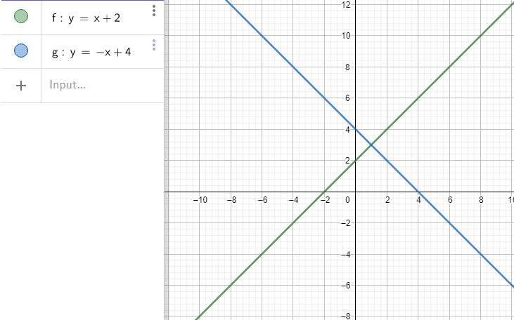 $\left[\begin{matrix}x' \\ y'\end{matrix}\right]=\left[\begin{matrix}-x+1 \\ y\end{matrix}\right]+ \left[\begin{matrix}1 \\ 0\end{matrix}\right]$

$\left[\begin{matrix}x' \\ y'\end{matrix}\right]=\left[\begin{matrix}-x+2 \\ y\end{matrix}\right]$

$⇒$ $\begin{matrix}x^{'} =-x+2 \\ y^{'}=y\end{matrix}$

Or $\begin{matrix}x =-x^{'}+2 \\ y=y^{'} \end{matrix}$

Now substitute in

**Original line** y = x+2

having points, A= (0, 2)

and B= (-1, 1) getting

**Reflected line $y^{'}=-x^{'}+ 4$**  having $A^{'}=(2,2)$ and $B^{'}=\left(3,1\right).$

Work to do:

**Q. Let y=x+3 be a line. Find its reflection along the line x= -1**